How to compile manifold DLL using VS2022

Open VS2022

Clone a repository

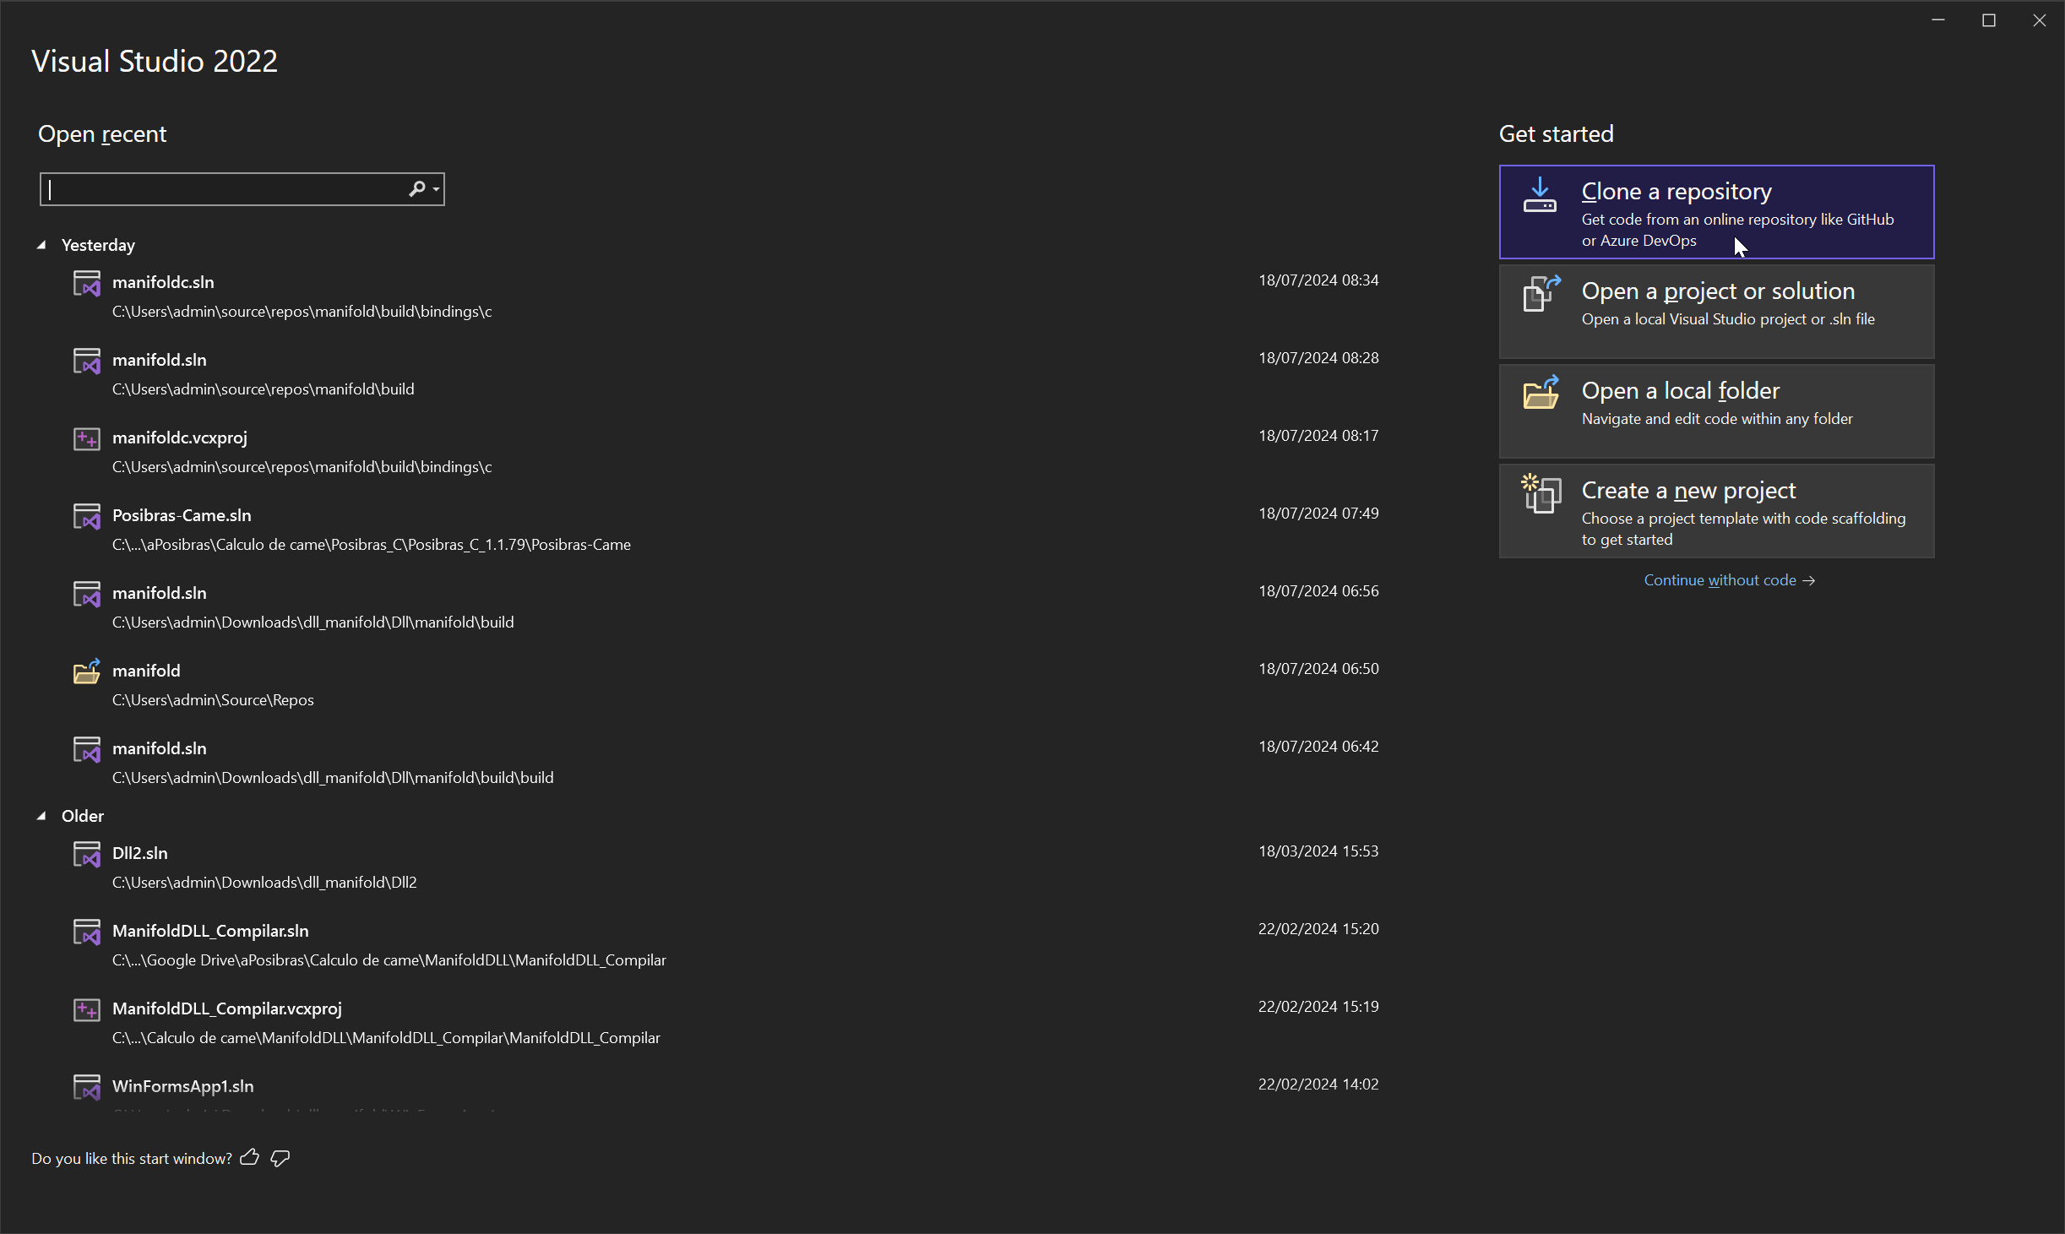

Repository location: <https://github.com/elalish/manifold>

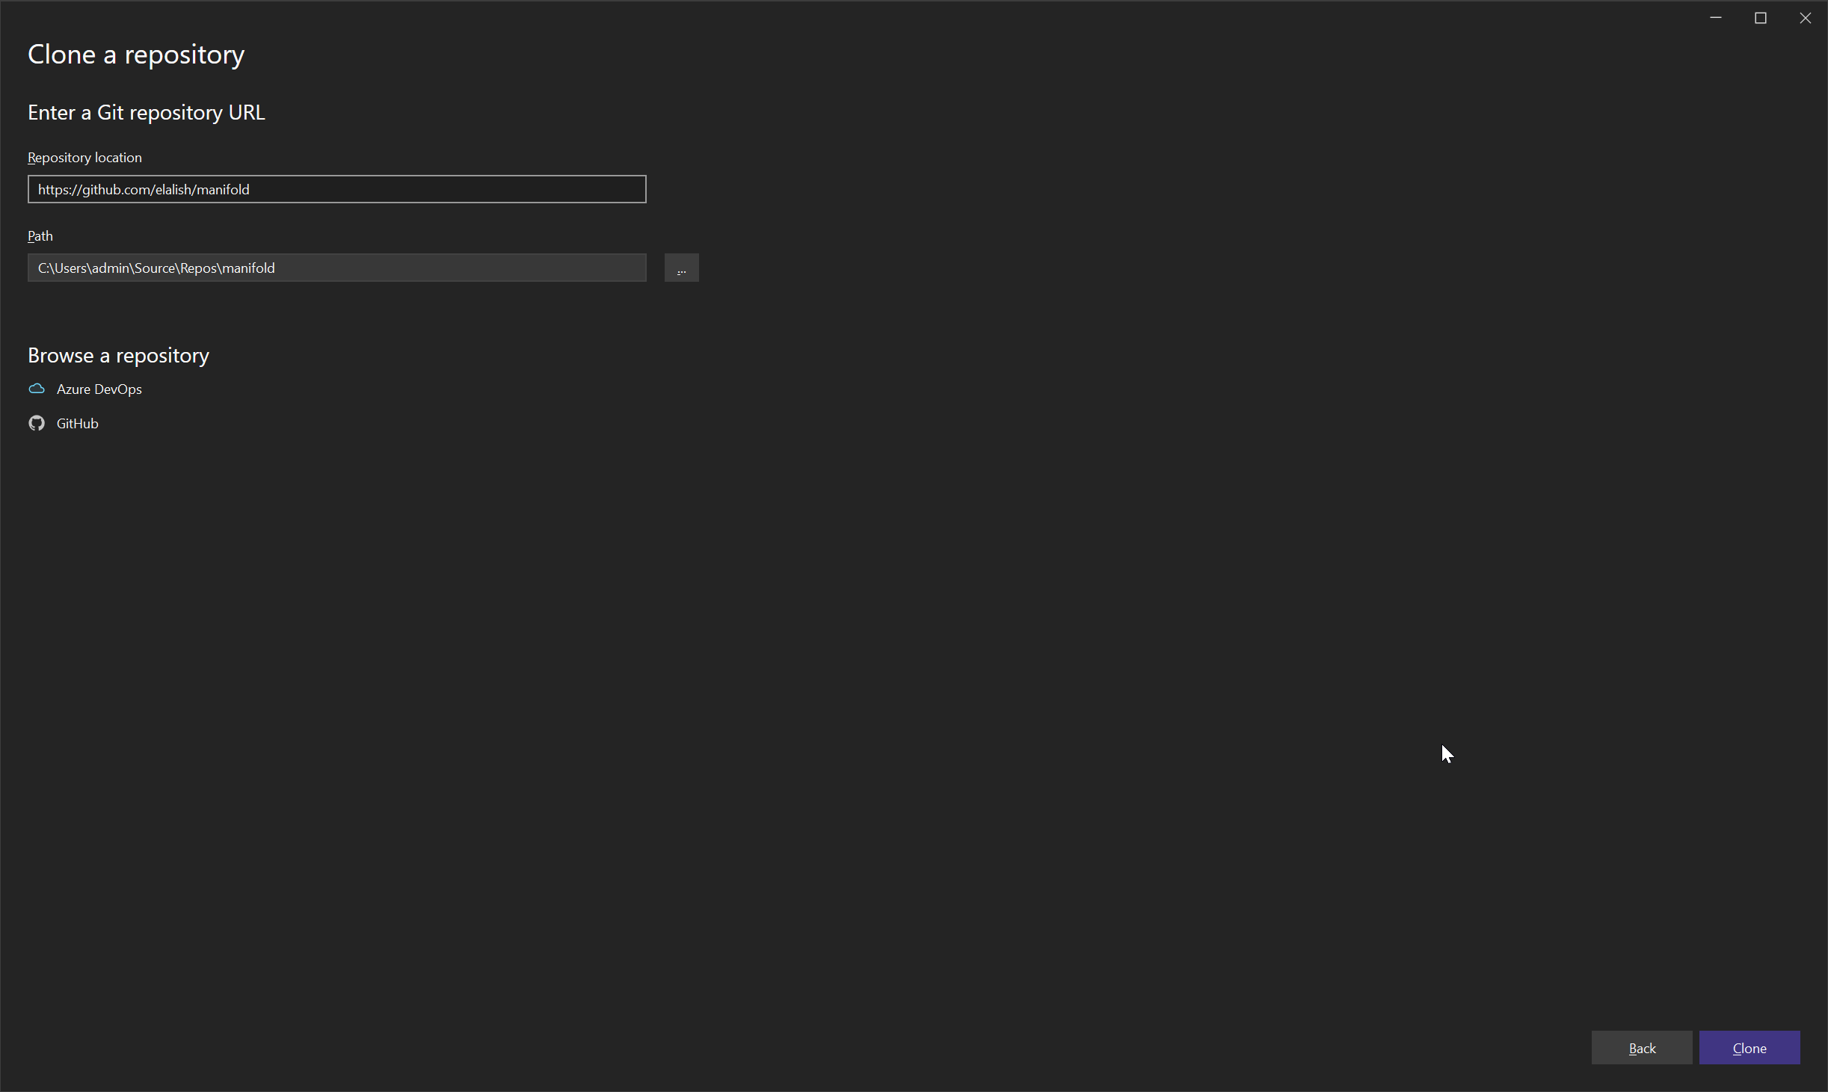

Wait download

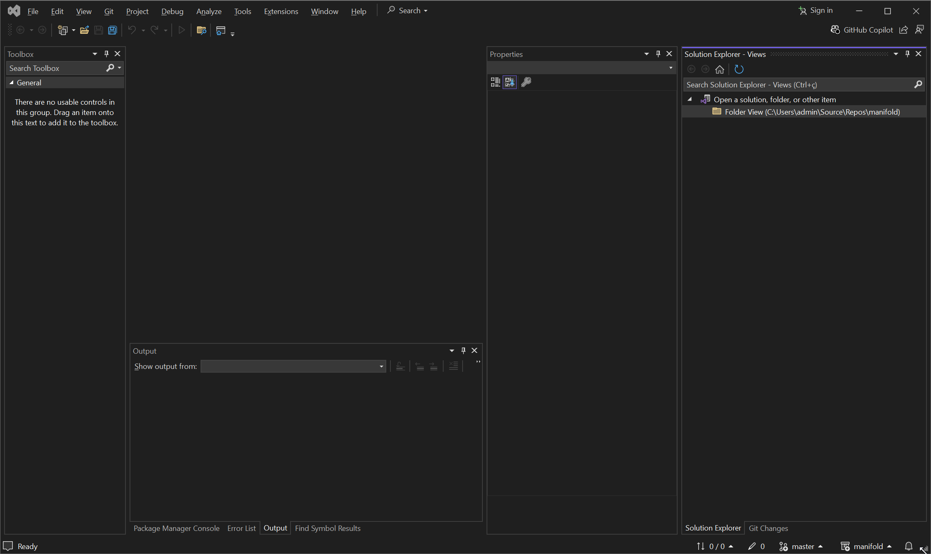

Go to the folder where manifold was installed:

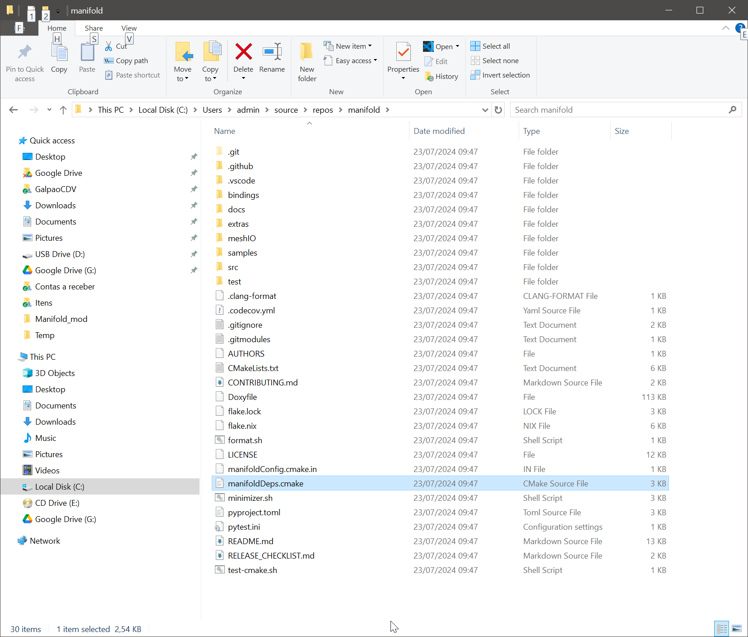

Replace the content of manifoldDeps.cmake to:

|  |
| --- |
| include(FetchContent)  include(GNUInstallDirs)  find_package(PkgConfig QUIET)  find_package(Clipper2 QUIET)  if(MANIFOLD_PAR STREQUAL "TBB")  find_package(TBB QUIET)  if(APPLE)  find_package(oneDPL QUIET)  endif()  endif()  if (PKG_CONFIG_FOUND)  if (NOT Clipper2_FOUND)  pkg_check_modules(Clipper2 Clipper2)  endif()  if(MANIFOLD_PAR STREQUAL "TBB" AND NOT TBB_FOUND)  pkg_check_modules(TBB tbb)  endif()  endif()  if(Clipper2_FOUND)  add_library(Clipper2 SHARED IMPORTED)  set_property(TARGET Clipper2 PROPERTY  IMPORTED_LOCATION ${Clipper2_LINK_LIBRARIES})  if(WIN32)  set_property(TARGET Clipper2 PROPERTY  IMPORTED_IMPLIB ${Clipper2_LINK_LIBRARIES})  endif()  target_include_directories(Clipper2 INTERFACE ${Clipper2_INCLUDE_DIRS})  else()  message(STATUS "clipper2 not found, downloading from source")  set(CLIPPER2_UTILS OFF)  set(CLIPPER2_EXAMPLES OFF)  set(CLIPPER2_TESTS OFF)  set(CLIPPER2_USINGZ "OFF" CACHE STRING "Preempt cache default of USINGZ (we only use 2d)")  FetchContent_Declare(Clipper2  GIT_REPOSITORY https://github.com/AngusJohnson/Clipper2.git  GIT_TAG ff378668baae3570e9d8070aa9eb339bdd5a6aba  GIT_PROGRESS TRUE  SOURCE_SUBDIR CPP  )  FetchContent_MakeAvailable(Clipper2)  if(NOT EMSCRIPTEN)  install(TARGETS Clipper2)  endif()  endif()  find_package(glm QUIET)  if(NOT glm_FOUND)  message(STATUS "glm not found, downloading from source")  set(GLM_BUILD_INSTALL "ON" CACHE STRING "")  FetchContent_Declare(glm  GIT_REPOSITORY https://github.com/g-truc/glm.git  GIT_TAG 1.0.1  GIT_PROGRESS TRUE  )  FetchContent_MakeAvailable(glm)  if(NOT EMSCRIPTEN)  install(TARGETS glm)  endif()  endif()  if(MANIFOLD_PAR STREQUAL "TBB" AND NOT TBB_FOUND)  message(STATUS "tbb not found, downloading from source")  include(FetchContent)  set(TBB_TEST OFF CACHE INTERNAL "" FORCE)  set(TBB_STRICT OFF CACHE INTERNAL "" FORCE)  FetchContent_Declare(TBB  GIT_REPOSITORY https://github.com/oneapi-src/oneTBB.git  GIT_TAG v2021.11.0  GIT_PROGRESS TRUE  )  FetchContent_MakeAvailable(TBB)  set_property(DIRECTORY ${tbb_SOURCE_DIR} PROPERTY EXCLUDE_FROM_ALL YES)  if(NOT EMSCRIPTEN)  install(TARGETS tbb)  endif()  endif()  if(MANIFOLD_EXPORT)  find_package(assimp QUIET)  if(NOT assimp_FOUND)  message(STATUS "assimp not found, downloading from source")  FetchContent_Declare(assimp  GIT_REPOSITORY https://github.com/assimp/assimp.git  GIT_TAG v5.2.5  GIT_PROGRESS TRUE  )  FetchContent_MakeAvailable(assimp)  if(NOT TARGET assimp)  add_library(assimp SHARED IMPORTED)  set_property(TARGET assimp PROPERTY  IMPORTED_LOCATION ${assimp_LINK_LIBRARIES})  if(WIN32)  set_property(TARGET assimp PROPERTY  IMPORTED_IMPLIB ${assimp_LINK_LIBRARIES})  endif()  target_include_directories(assimp INTERFACE ${assimp_INCLUDE_DIRS})  if(NOT EMSCRIPTEN)  install(TARGETS assimp)  endif()  endif()  endif()  endif() |

IN VS2022, click on Tool / Command Line / Developer Command Prompt

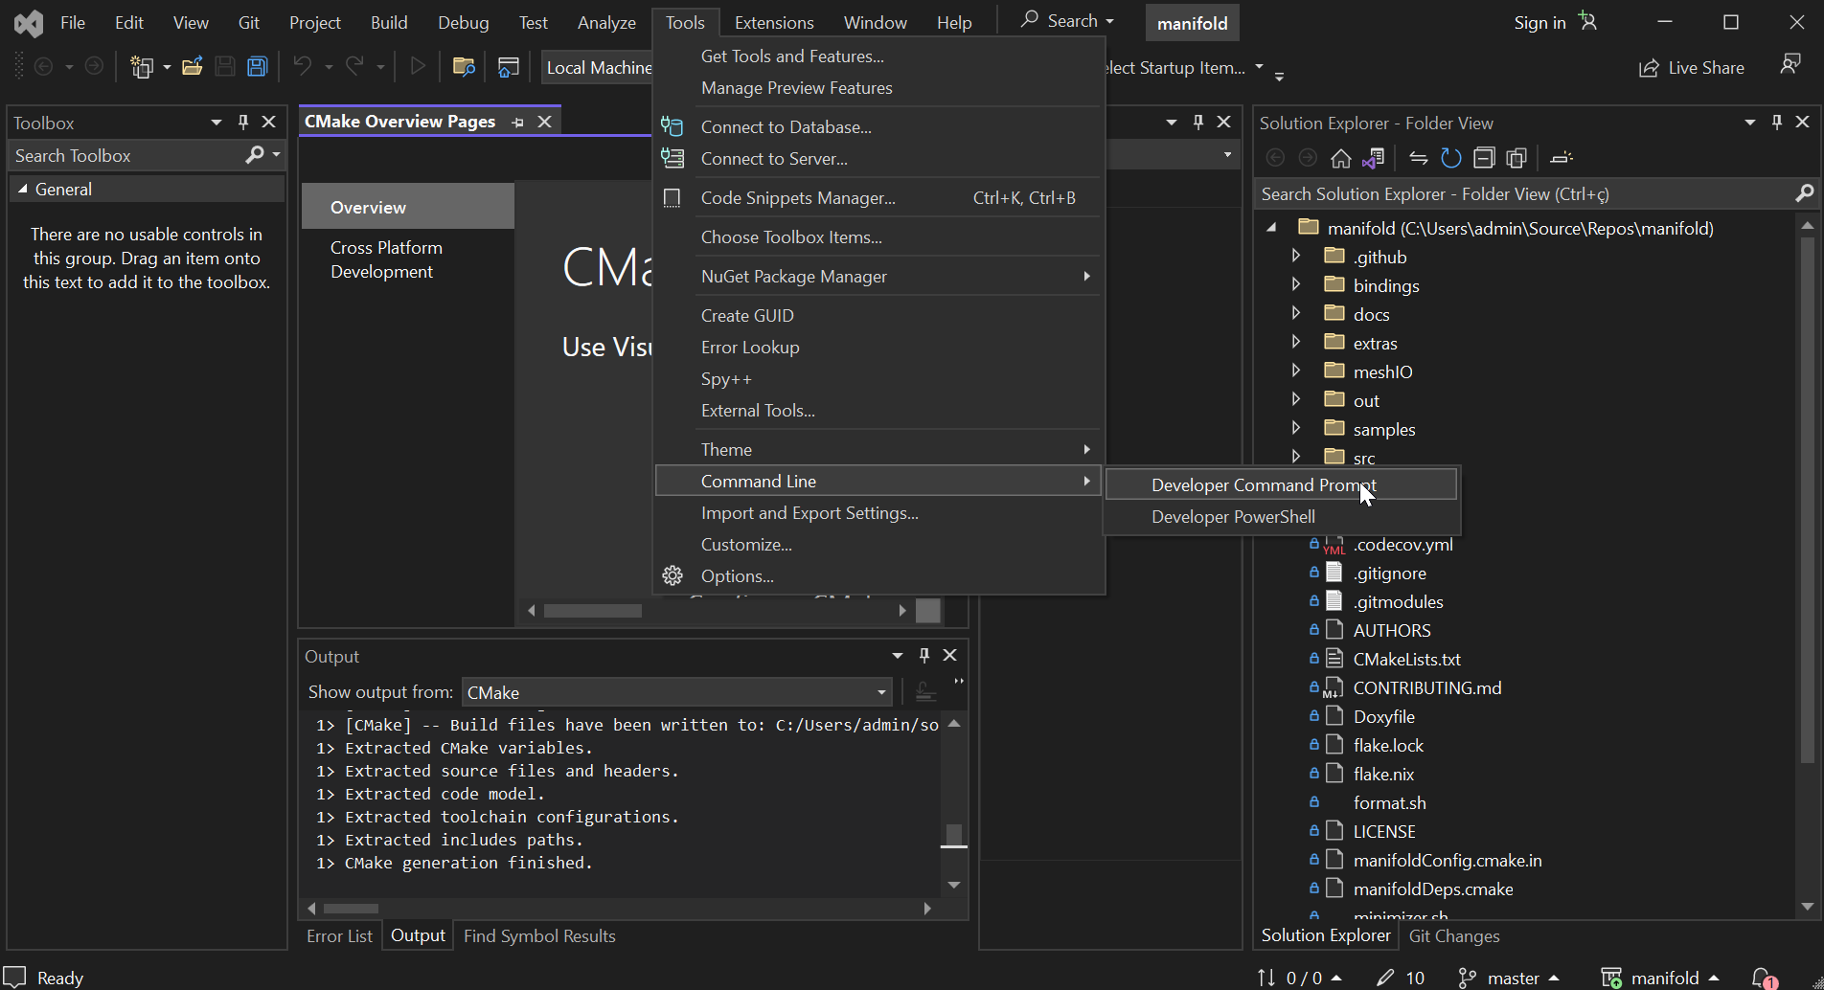

It will open a command prompt.

Run:

cmake . -DCMAKE_BUILD_TYPE=Release -DBUILD_SHARED_LIBS=OFF -DMANIFOLD_DEBUG=ON -DMANIFOLD_PAR=TBB -DMANIFOLD_EXPORT=ON -A x64 -B build

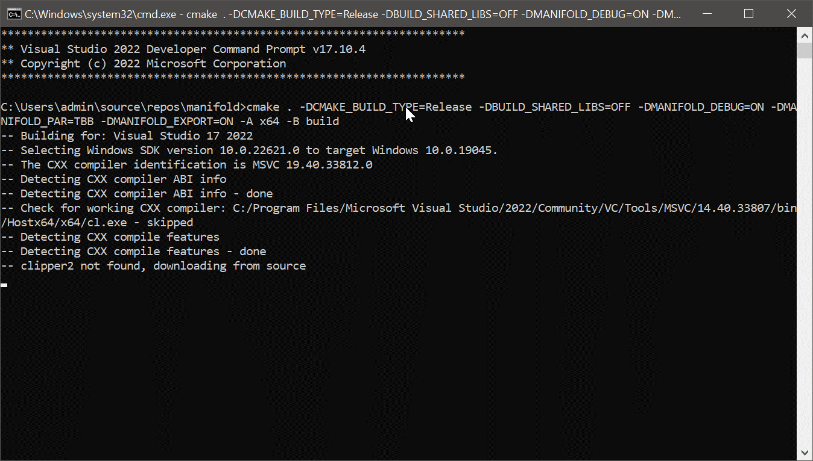

The step above will create a folder in manifold\build\bindings\c

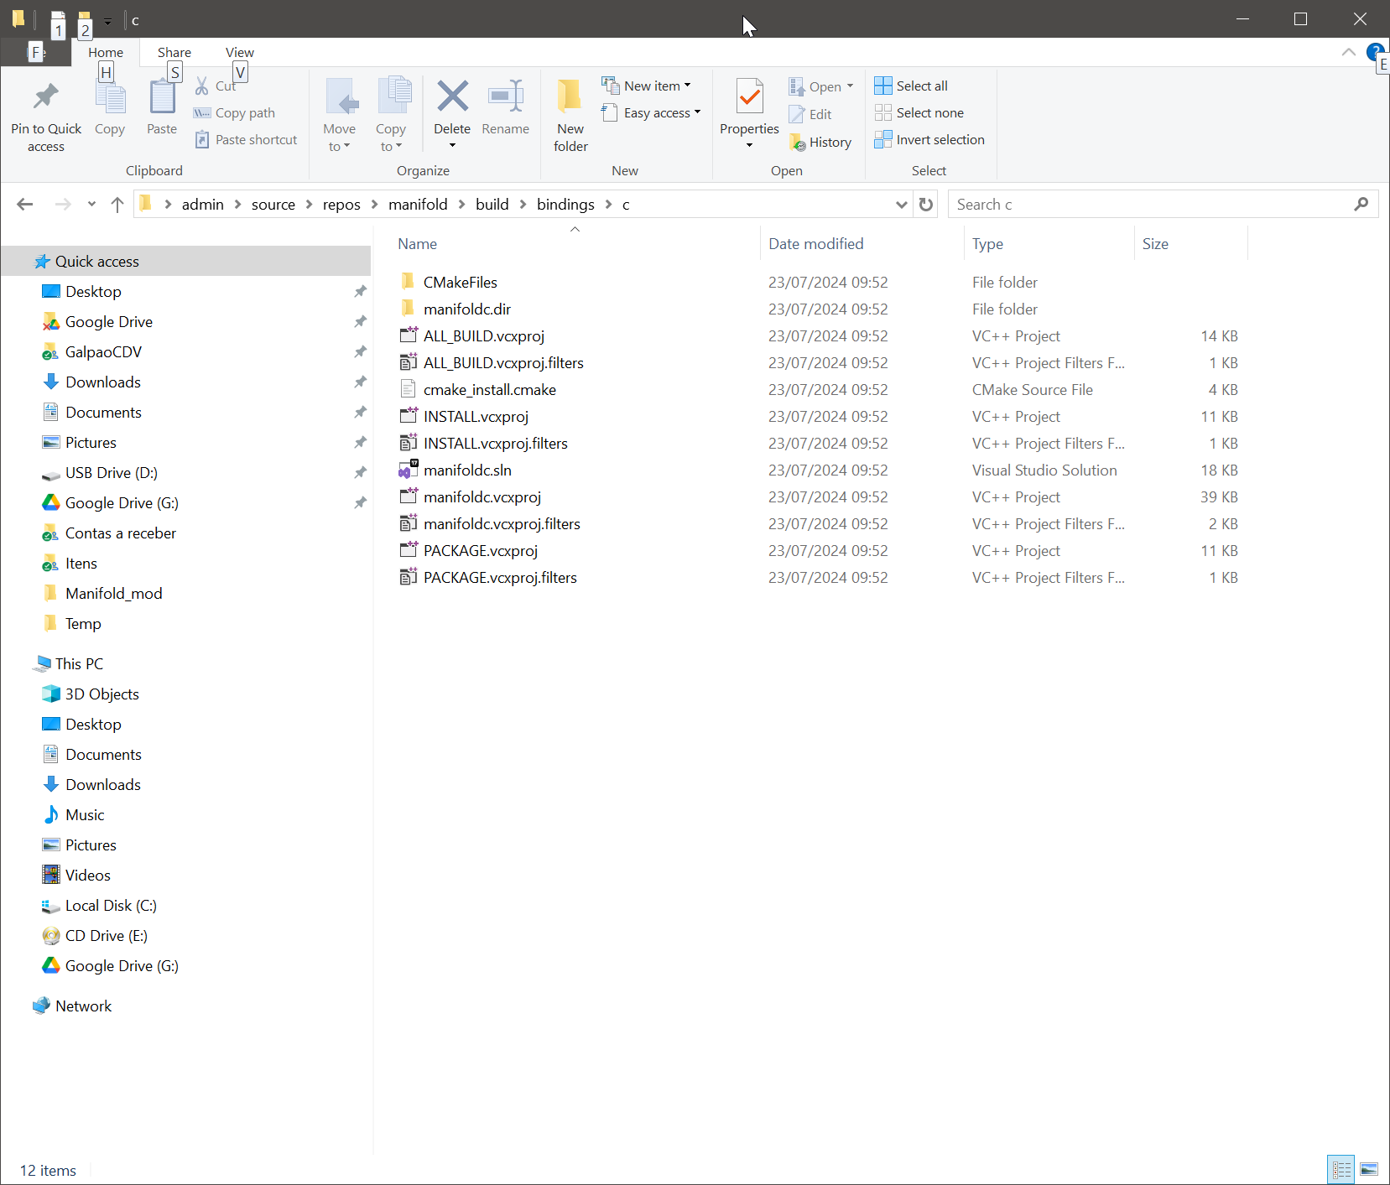

Close the Command prompt screen and also close VS2022

Open a new VS2022 anc click on Open a project or solution

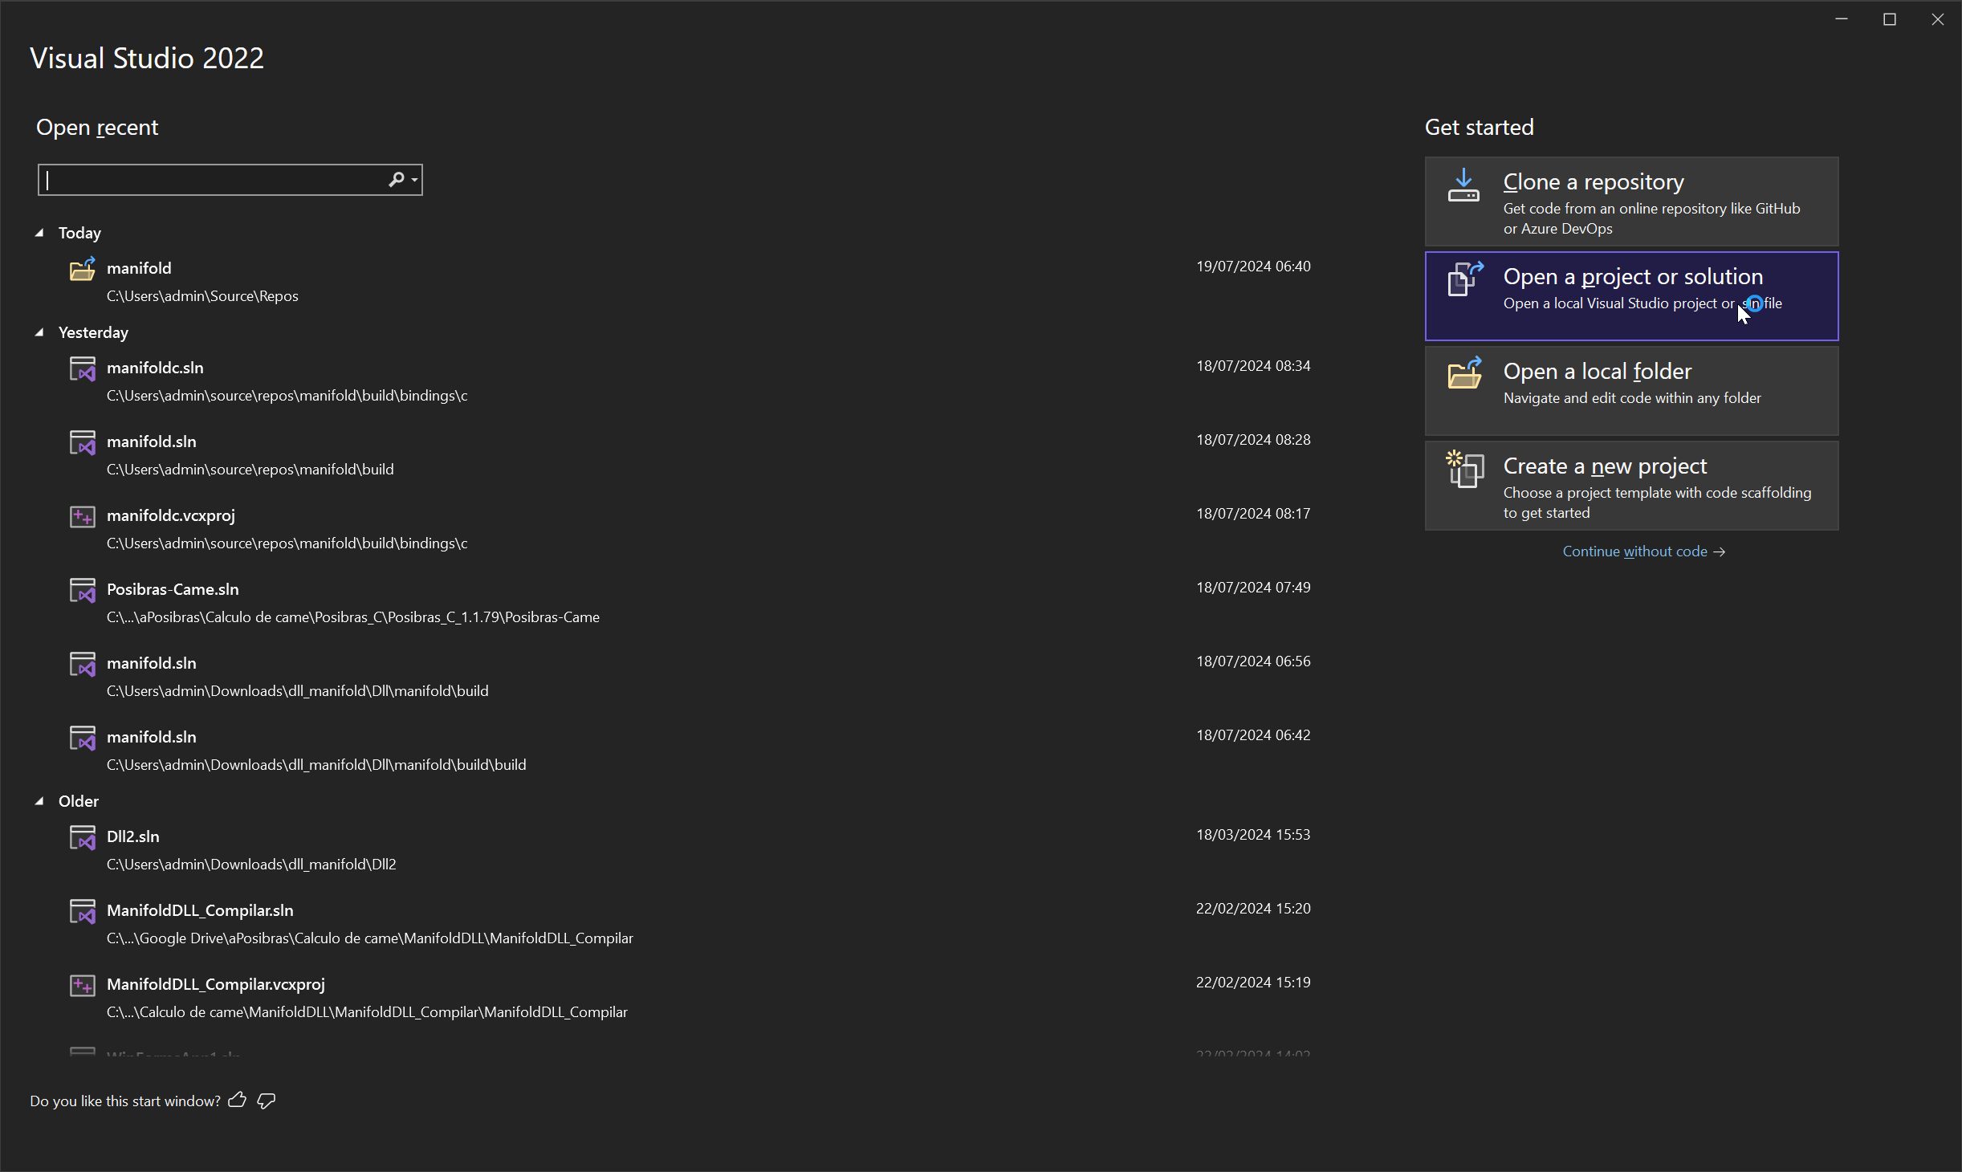

**Open the file manifoldc.vcxproj**

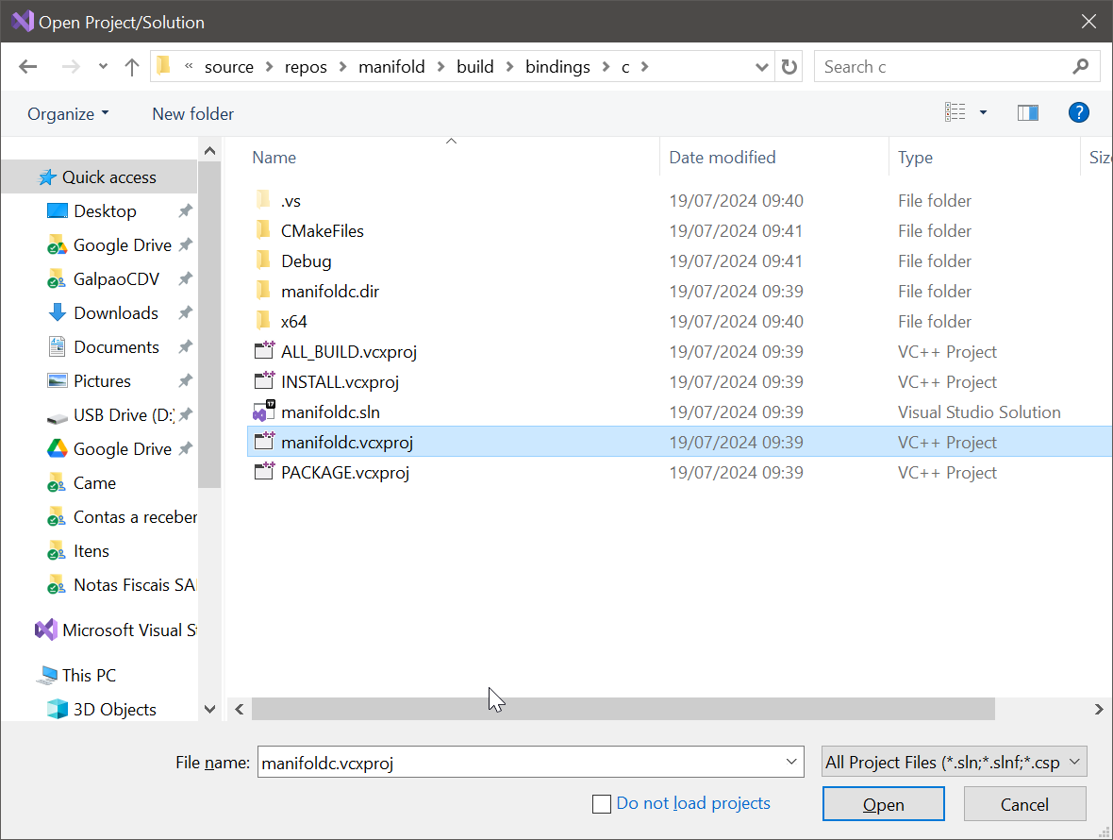

Select Release or Degub

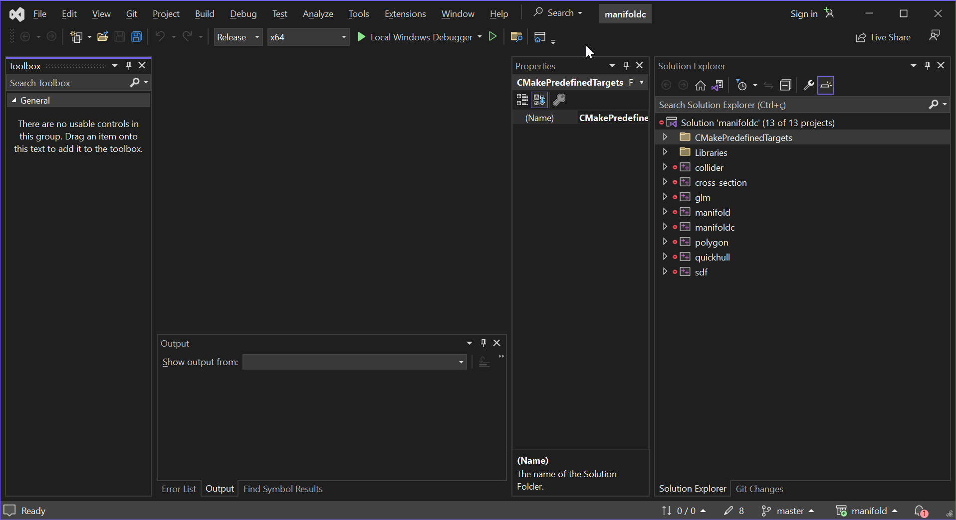

Right click on Solution ‘manifoldc’ and click on Build Solution

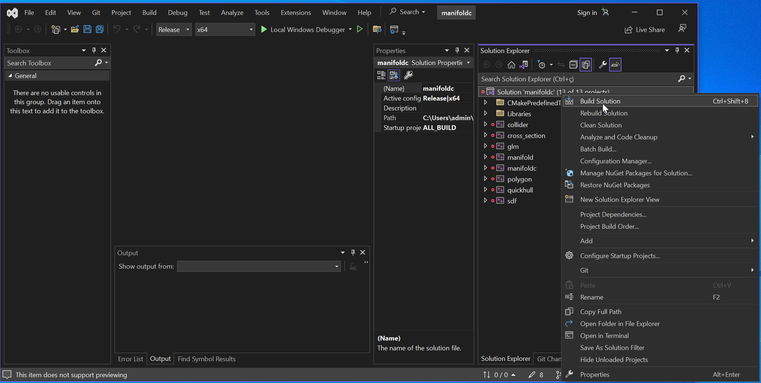

The DLL will be created on

manifold\build\bin\Release\manifoldc.dll (Release version)

or

manifold\build\bin\Debug\manifoldcd.dll (Debub version)

Sample program in C#

|  |
| --- |
| // See https://aka.ms/new-console-template for more information  using System;  using System.Runtime.InteropServices;  using System.Text;  class Program  {  static void Main(string[] args)  {  const string DllPath = @"C:\Users\admin\manifold\build\bin\Release\manifoldc.dll ";  [DllImport(DllPath, CallingConvention = CallingConvention.Cdecl)]  static extern nuint manifold_cylinder(nuint mem, float height, float radiusLow, float radiusHigh, int circularSegments, int center);  [DllImport(DllPath, CallingConvention = CallingConvention.Cdecl)]  static extern nuint manifold_get_meshgl(nuint mem, nuint manifold_ptr);  [DllImport(DllPath, CallingConvention = CallingConvention.Cdecl)]  static extern void manifold_export_meshgl([MarshalAs(UnmanagedType.LPStr)] string file_path, nuint mesh_ptr,nuint export_options_ptr);  [DllImport(DllPath, CallingConvention = CallingConvention.Cdecl)]  static extern nuint manifold_export_options(nuint mem);  nint addr_export_opt = Marshal.AllocHGlobal(96); // Size of class ExportOptions: 96 bytes  addr_export_opt = (nint)manifold_export_options((nuint)addr_export_opt);  nint addr = Marshal.AllocHGlobal(16); // Size of class manifold: 16 bytes  addr = (nint) manifold_cylinder((nuint)addr, 10.0f, 5.0f, 5.0f, 360, 1);  nint addr_mesh = Marshal.AllocHGlobal(304); // Size of class Mesh: 304 bytes  addr_mesh = (nint)manifold_get_meshgl((nuint)addr_mesh,(nuint)addr);    string file = "test.glb";    manifold_export_meshgl(file, (nuint)addr_mesh, (nuint)addr_export_opt);  return;  }  } |