S.No | Issue | Issue screenshot
1 | The SfDateRangePicker has a Syncfusion site hyper link.  SfDateRangePicker - SfDateRangePicker class - datepicker library - Dart API  Or  Flutter Date Range Picker - Flutter Date Range Picker - Rich UI for Date Ranges | Syncfusion  Or the existing one is correct?  SfDateRangePicker - Flutter Date Range Picker - Rich UI for Date Ranges | Syncfusion | 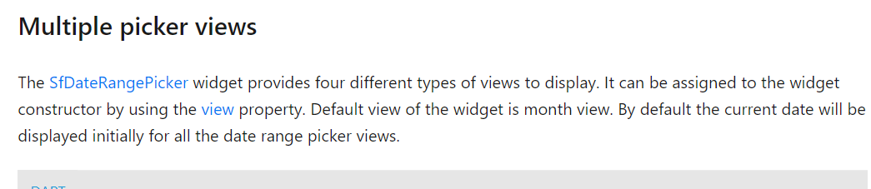
2 | DateRangePicker to SfDateRangePicker | 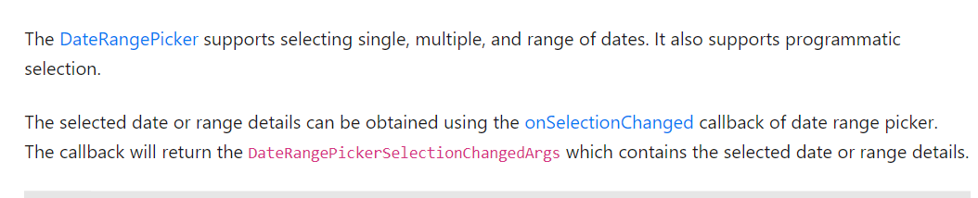
3 | Eg (example) looks separate. | 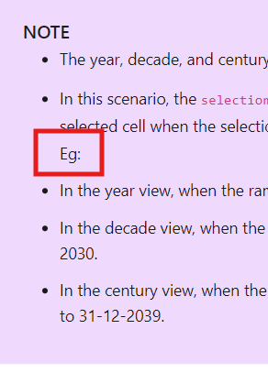  Selections in Flutter Date Range Picker widget | Syncfusion
4 | Totally 5 selection mode available only 4 mentioned | 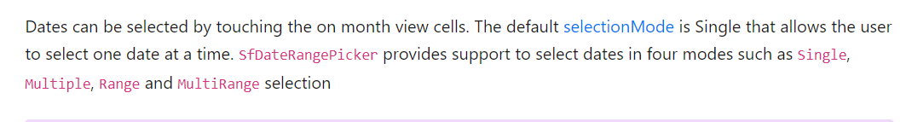
5 | Space needed after comma | 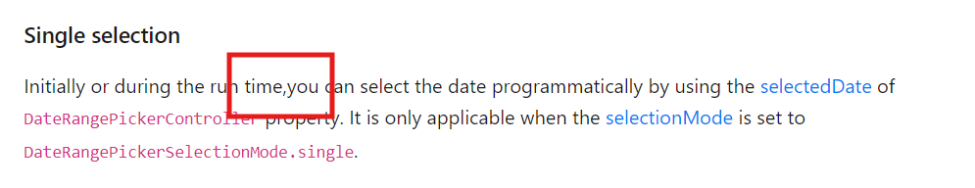  Date Navigations in Flutter Date Range Picker widget | Syncfusion
6 | Week, day views are not available the descriptions are wrong | 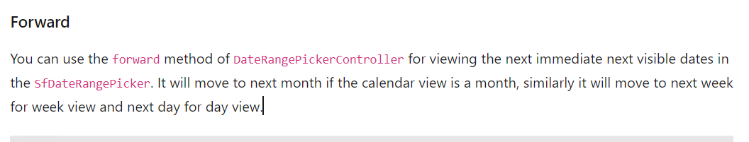  Forward - Date Navigations in Flutter Date Range Picker widget | Syncfusion  Backward - Date Navigations in Flutter Date Range Picker widget | Syncfusion
7 | First line in description is not related to the topic | 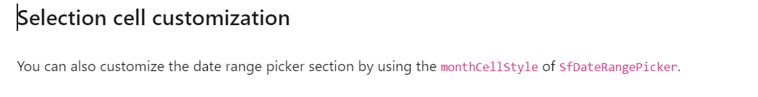  Customizations in Flutter Date Range Picker widget | Syncfusion
8 | API name and API links are wrong | 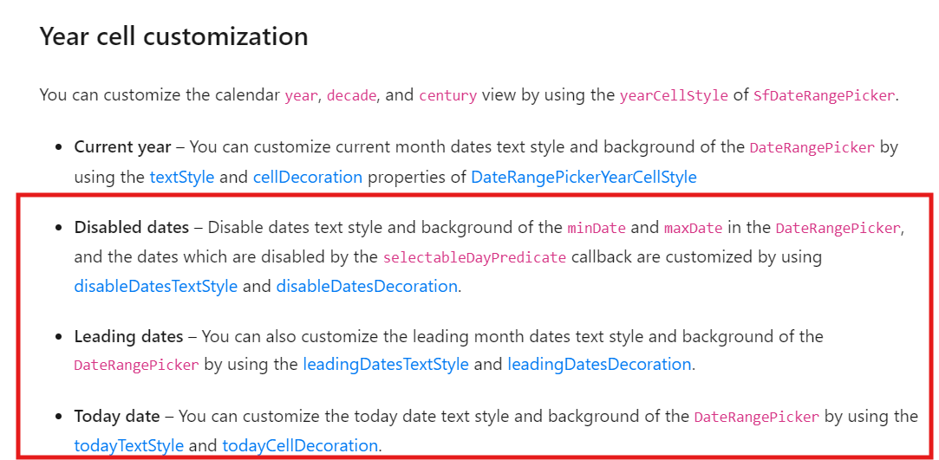  Customizations in Flutter Date Range Picker widget | Syncfusion
9 | Update DateRangePicker instead of Calendar in first line of description | 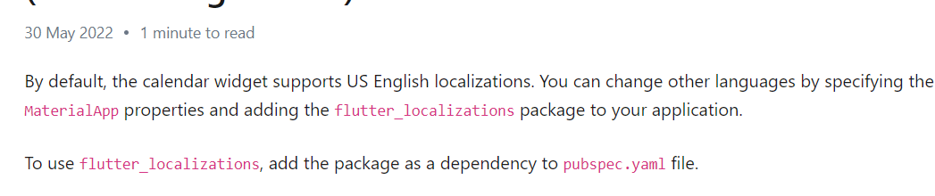  Localization in Flutter Date Range Picker widget | Syncfusion
10 | API link not added | 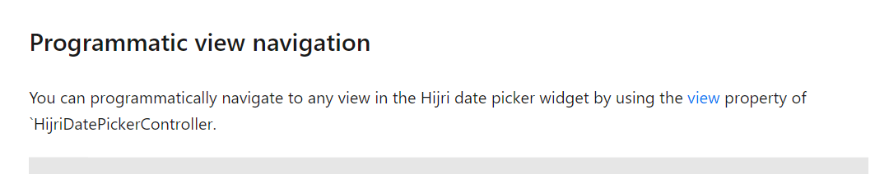
11 | Need to mention Hijri | 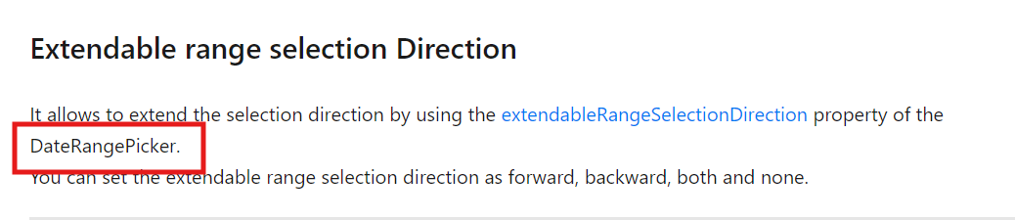
12 | API link is wrong | 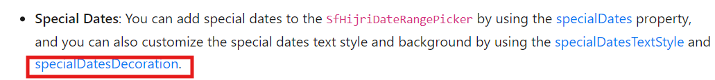  About Flutter Hijri Date Range Picker widget | Syncfusion | DatePicker

